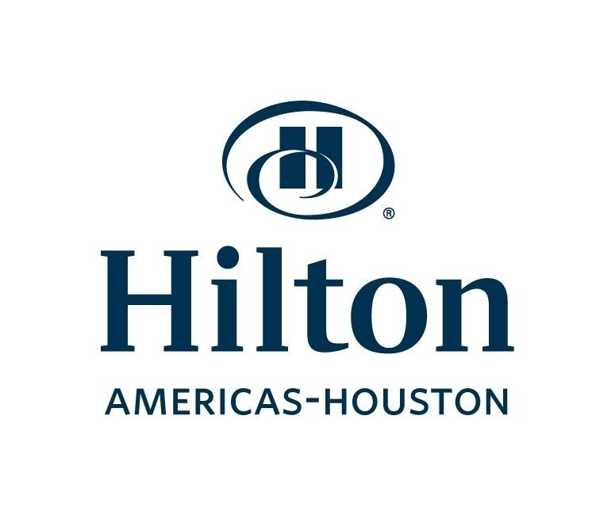
4/19/2016

Hilton Overnight Cleaning LOC - RFP Questions

- We know you don't want a cost per square foot but is it possible to get the cleanable square foot per area per floor to clean, excluding restrooms?
Do not have the exact square footage.

- Due to the recent bad weather is it possible to get an extension on submitting the bid?
Bids will be accepted through this Friday at 4pm.

- Once awarded the project, will the new contractor receive hotel ID badging or do we provide our own company ID badging? What all is required for worker access? For example, background check (how many years?), drug testing, etc?
Vendor to provide own name tags and all contractors will sign in daily.

- We know that power washing is required in the kitchens. What is being used currently? I am aware that gas power washing will need to be vented. How is power washing handled on upper floors?
Current Vendor is using an electric power washer.

- Is there a prevailing wage rate to adhere to by Hilton?
Wage rate to be determined by vendor to meet or exceed minimum state and federal guidelines.

- Are there any recurring or specific issues that you would prefer for the awarded contractor to focus on for this bid?
Scope of work completed daily, weekly and monthly is what we’re looking for.

- It appears that currently the allotted work hour shift is from 11p-6a and about 7 hrs per day. Would you consider extending that to an 8 hr shift which will help decrease turnover percentage?
There are certainly some nights that the contractor can start early but due to how our business falls most of the time 8am is difficult due to our hours of operation. However there are many nights 2,3 and 4th floors areas can be started at 10pm instead of 11pm.

- Would you have any objection to winning bidder retaining any incumbant workers?
Attaining work force will be up to the vendor.

- For clarification, does the term "Diamond Polish" mean use of a diamond polish pad to polish lobby floor?
Yes.

- The Contractor Utilization Plan asks for the Total Bid Value and the approximate dollar value of the subcontracting amount. Should we put the monthly or annual dollar amount?
Yes.

- It also asks for a start and end date. Can that be left blank or TBD since this is not a one-time project but an ongoing monthly service contract?
Start Date July 1st-Reviewed Annually.

- The Instructions to Bidders lists acceptable certification sources. It does not list a Texas HUB certificate. Is this acceptable?
HUB certifications are acceptable as noted by the acceptance of HMSDC as one of the acceptable certifying agencies. HMSDC certifies MBE’s, MWBE’s, and HUBs, therefore Texas HUB certificates are acceptable.

- It was stated that, even though a company maybe 100% MBWE owned, it is still a requirement to have 33% subcontracted to MBWE. For clarification regarding, that only applies IF the bidder intends to subcontract any of the work. If the bidder intends to do all of the work in-house with no subcontracting, that 33% requirement does not apply, correct? However, the bidding company itself should be a MBWE company to meet the 25% weighing evaluation factor, correct?
The HoustonFirst Corporation (HFC) Supplier Diversity Program is a subcontractor program. Compliance with the HFC Supplier Diversity Program requires the 33% diversity subcontractor participation goals established for the solicitation must be met without regard to the diversity status of the prime contractor (s) that are responding to the solicitation. However any diversity prime contractor (s)/vendors that are responding should identify themselves as diversity companies and provide verification of their certification status.

- Can you identify/name the exact number of kitchens included in the RFP?
1st floor, 2nd floor,4th floor Fully Functional Kitchens

- Will Hilton or the vendor provide communication equipment for overnight cleaning staff?
Vendor to provide

- What is the contract’s anticipated start date?
July 1st based on BOD Approval

- Can you restate the minimum insurance requirements?
$5Million GA, $1M Auto & $1M Workers Comp.

- Aside from cleaning guest and parking elevators, are there any additional cleaning tasks associated with the parking garage?
Garage Elevators are no longer a part of the contract.

- Who provides the escalator machine for cleaning the elevator?
Vendor supplies own.

- How often is the loading dock expected to be cleaned?
To be power washed? Daily Sweep and Power Washed once a week

- Can you restate vendor’s responsibility for cleaning specific kitchen equipment like ranges, ovens, combi-ovens, and walk in coolers and freezers?
Walkin Freezers & Cooler Doors has to be cleaned on the outside only. All Kitchen equipment cleaned thoroughly daily

- According to the Houston First Diversity Program, the following are acceptable certification sources for a Prime vendor to qualify a company to subcontract 33% of the contract’s total revenue:
• City of Houston
• Houston Minority Supplier Development Council
• METRO’s Small Business Certification Program
• Women’s Business Enterprise Alliance
• Texas Department of Transportation’s Unified Certification Program
• Texas Small Business Association
HUB is not listed above. Would a HUB certified subcontractor be acceptable?
See Question 3

- On floors 2-3-4 is vendor responsible for high dusting? Example, ceiling vents, lighting, etc.? What about 1st and part of 2nd floor where the ceilings are over 20 feet?
For Back of the house all high dusting is part of the contract. Front of the House dusting up to 15ft on 2nd, 3rd and 4th floors

